Name – Yash Morankar

Roll Number – TECOB220

**Contents of all 6 Tables:-**

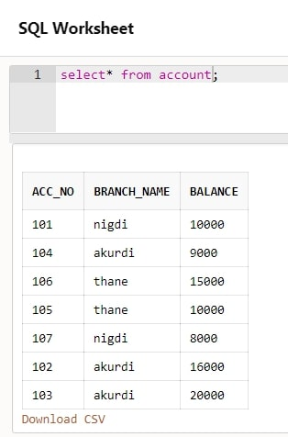 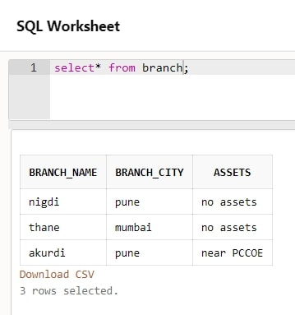

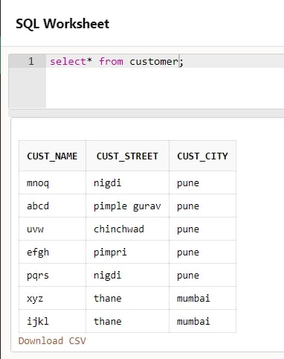 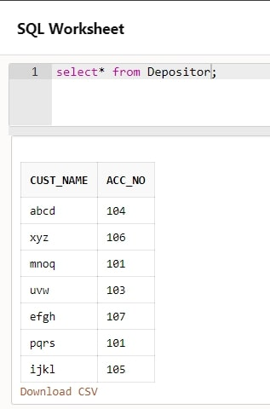

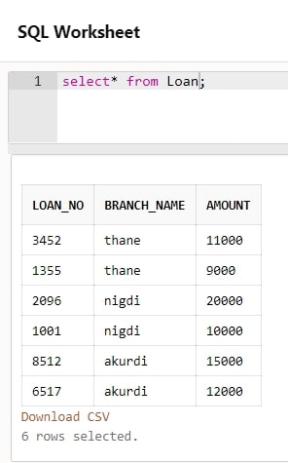 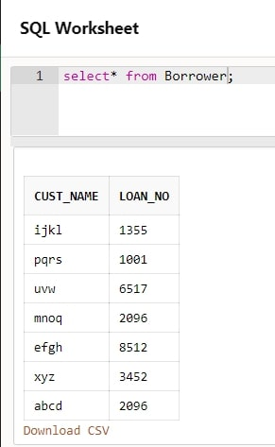

**Queries:-**

1. **Find the names of all branches in loan relation.**

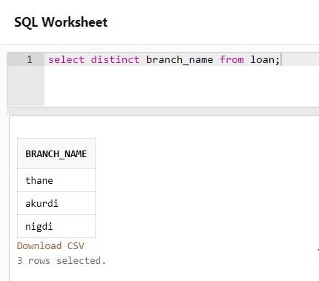

1. **Find all loan numbers for loans made at Akurdi Branch with loan amount > 12000.**

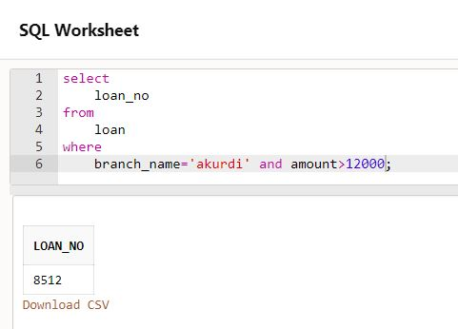

1. **Find all customers who have a loan from bank. Find their names, loan_no and loan amount.**

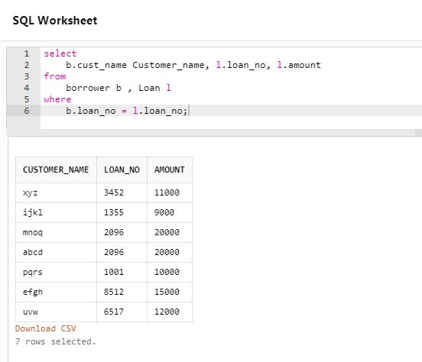

1. **List all customers in alphabetical order who have loan from Akurdi branch.**

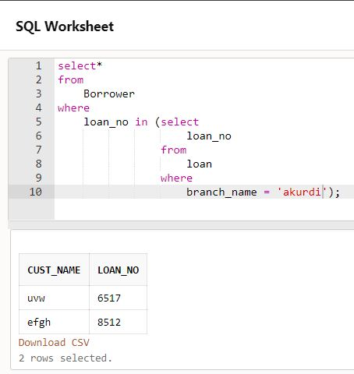

1. **Find all customers who have an account or loan or both at bank.**

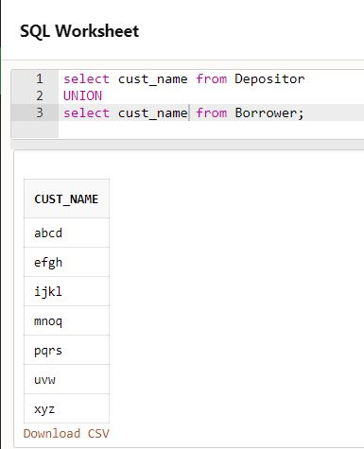

1. **Find all customers who have both account and loan at bank.**

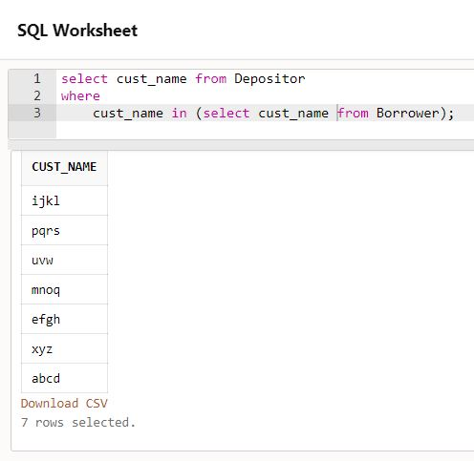

1. **Find all customer who have account but no loan at the bank.**

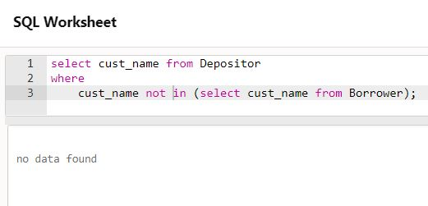

1. **Find average account balance at Akurdi branch.**

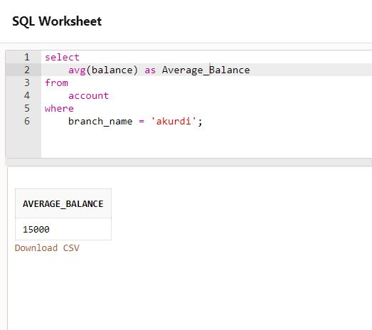

1. **Find the average account balance at each branch**

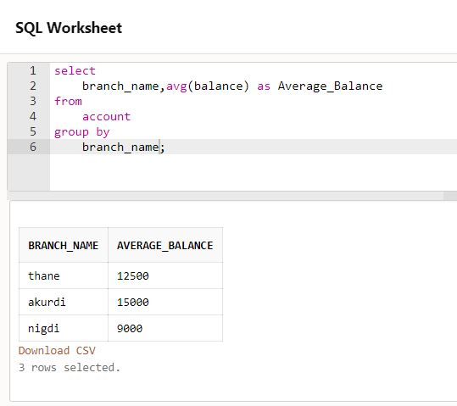

1. **Find no. of depositors at each branch.**

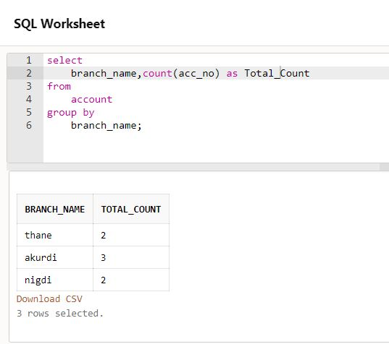

1. **Find the branches where average account balance > 12000.**

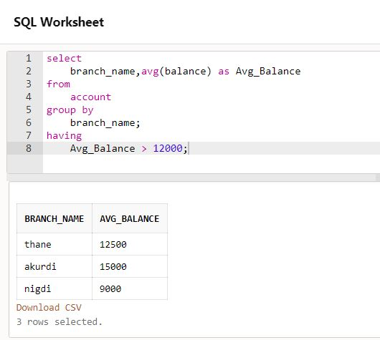

1. **Find number of tuples in customer relation.**

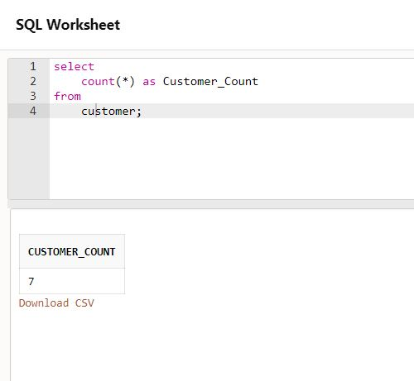

1. **Calculate total loan amount given by bank.**

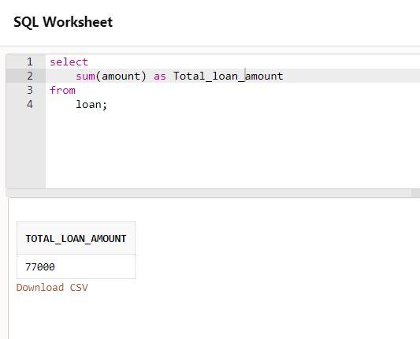

1. **Delete all loans with loan amount between 13000 and 15000.**

**Before Deletion:-**

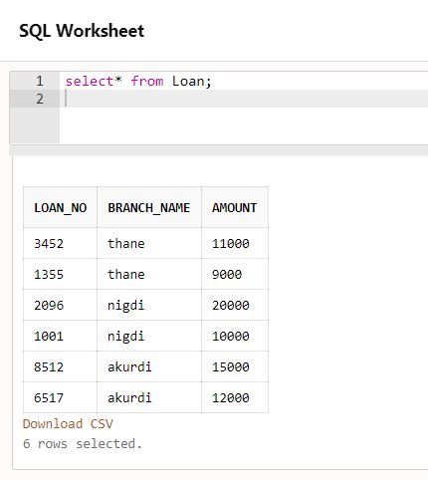

**After Deletion:-**

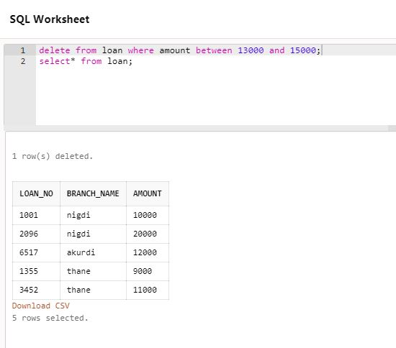

1. **Delete all tuples at every branch located in Pune.**

**Before Deletion:-**

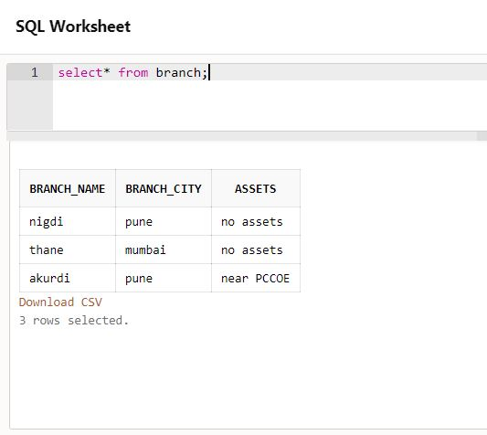

**After Deletion:-**

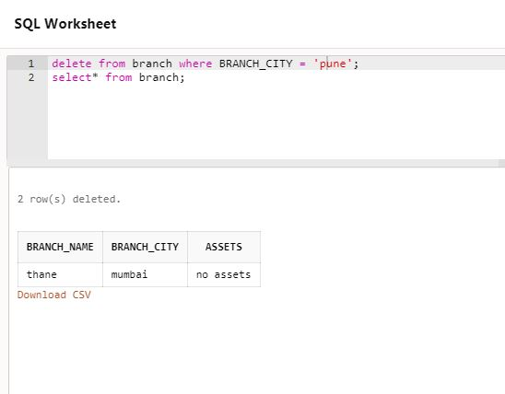

1. **Create synonym for customer table as cust.**

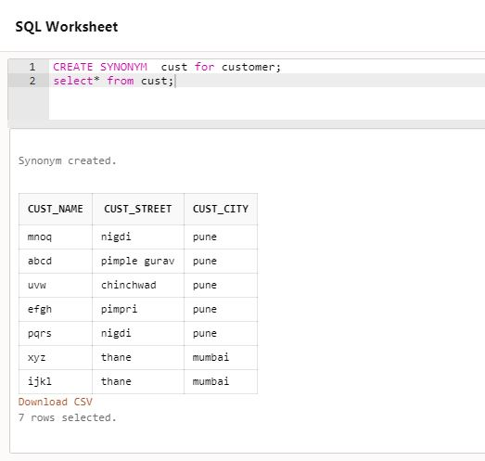

1. **Create sequence roll_seq and use in student table for roll_no column.**

